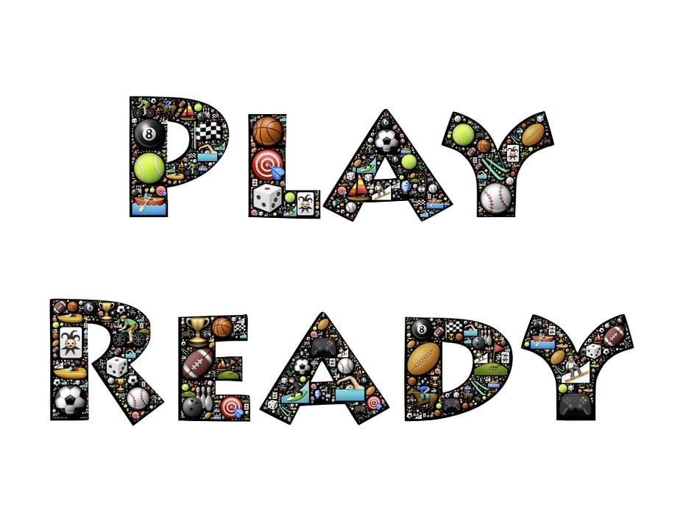
- Bookbags are not allowed in class – you have been assigned a lock and a locker.

- Locker times are at the beginning of each school day (before homeroom/advisory period) and at the end of each school day (dismissal from your 5th period class).

- Eating food items and drinking of beverages are not allowed in our hallway.

- Keep our learning community clean and attractive – take P.R.I.D.E.

